UNIT 3 — FORCES AND MOTION · TEACHER KEY  Free-Body Diagrams | U03  PRACTICE SET · ANSWER KEY

1. A box of books sits at rest on a level floor. Draw the free-body diagram for the box. |  | 2. A crate on smooth, frictionless ice is pushed horizontally to the right and speeds up. Ignore air resistance. Draw the free-body diagram for the crate. |  | 3. A dresser is pushed horizontally to the right across a rough wooden floor at a constant speed. Ignore air resistance. Draw the free-body diagram for the dresser.
• WARM-UP  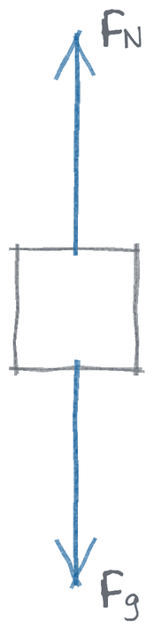 |  | • WARM-UP  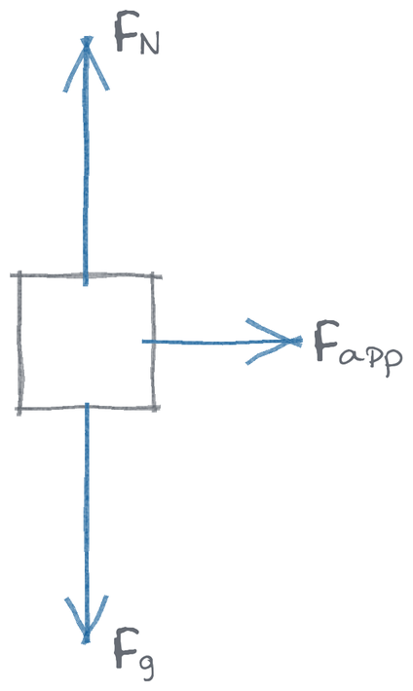 |  | • WARM-UP  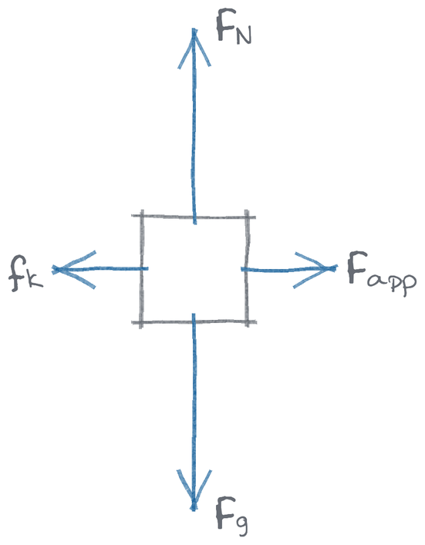
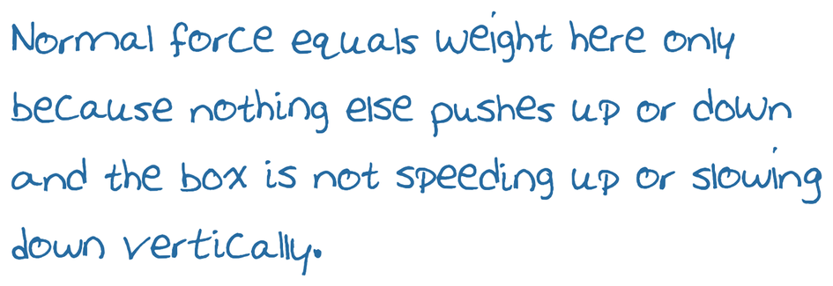 |  |  |  | 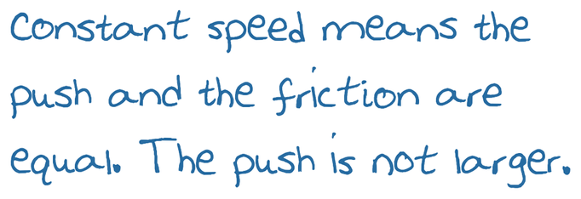

4. A hockey puck slides to the right across rough ice and slows to a stop. Nothing is pushing it. Ignore air resistance. Draw the free-body diagram for the puck while it is still sliding. |  | 5. A framed picture hangs freely, not touching the wall, from two ropes. One rope pulls up and to the left and the other pulls up and to the right, each at 50° above the horizontal. Draw the free-body diagram for the picture. |  | 6. A person stands on a bathroom scale in an elevator. The elevator is moving up and speeding up. Draw the free-body diagram for the person.
• PRACTICE  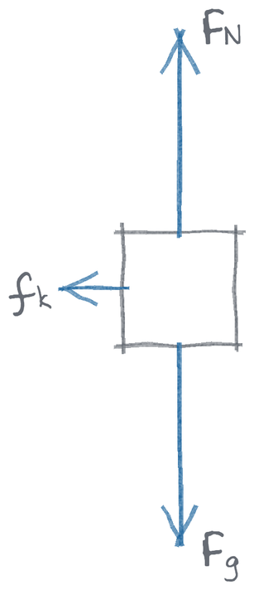 |  | • PRACTICE  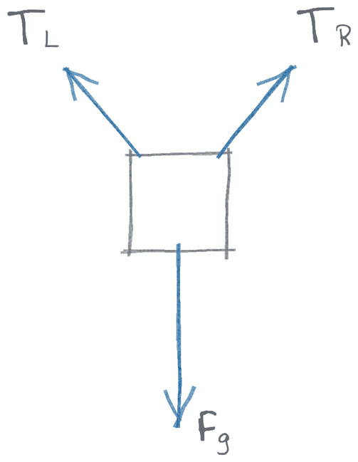 |  | • PRACTICE  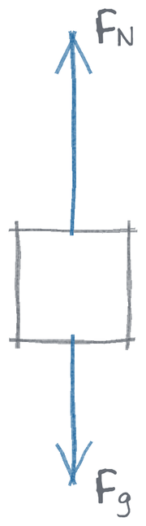
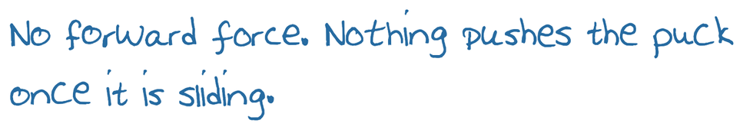 |  | 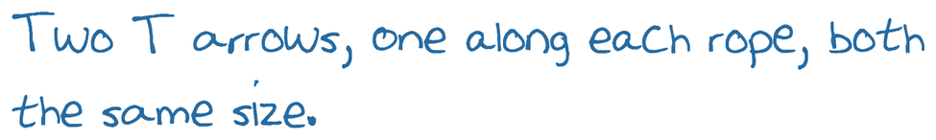 |  | 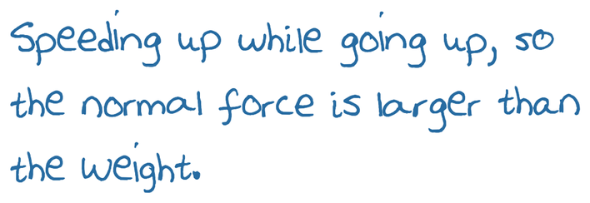

7. A skydiver falls toward the ground and is still speeding up. Air resistance acts on her. Draw the free-body diagram for the skydiver. |  | 8. A sled is pulled to the right across rough snow at a constant speed. The rope pulls at 30° above the horizontal. Ignore air resistance. Draw the free-body diagram for the sled. |  | 9. A toolbox sits at rest on a rough ramp tilted 25° above the horizontal. Draw the free-body diagram for the toolbox.
• PRACTICE  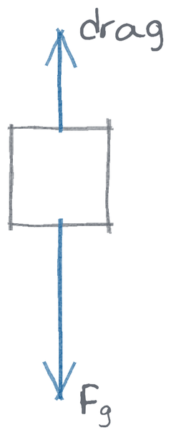 |  | • CHALLENGE  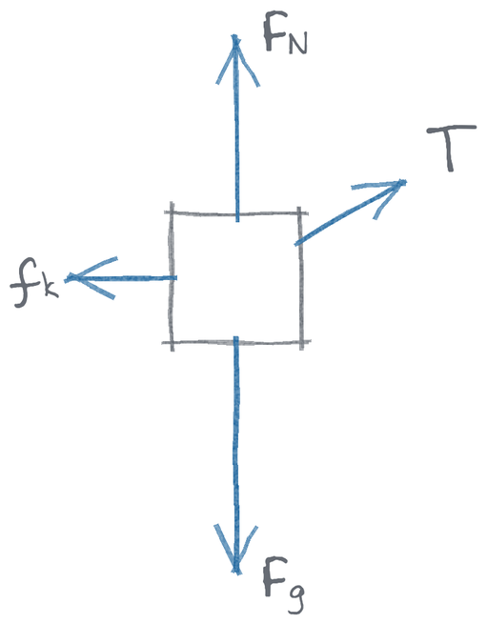 |  | • CHALLENGE  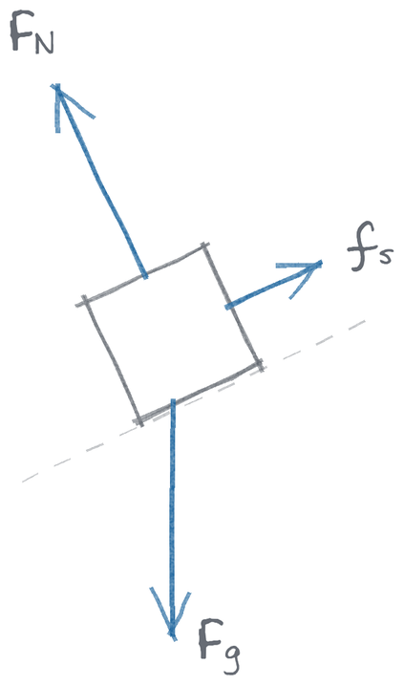
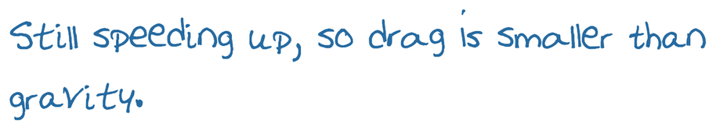 |  | 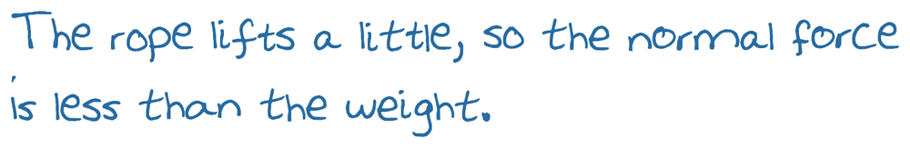 |  | 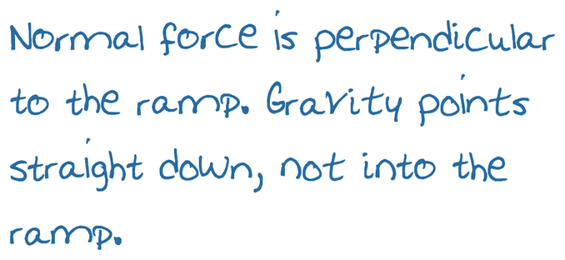

10. A wooden block slides down a rough ramp tilted 25° above the horizontal and speeds up as it goes. Ignore air resistance. Draw the free-body diagram for the block. |  | 11. A book rests on a table, and the table stands on a level floor. Nothing is moving. Draw two separate free-body diagrams: one for the book and one for the table.
• CHALLENGE  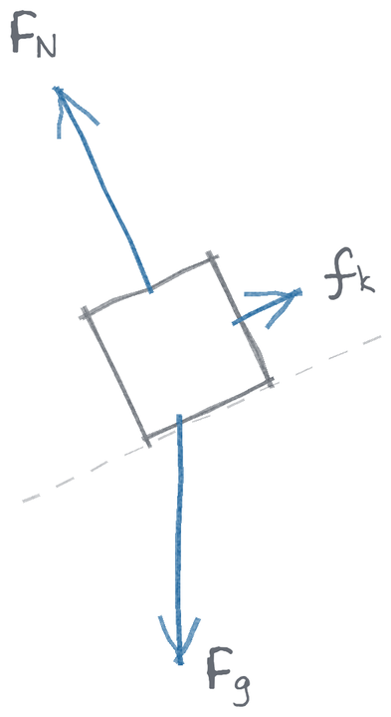 |  | Book • CHALLENGE  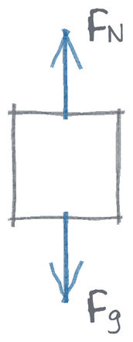 |  | Table  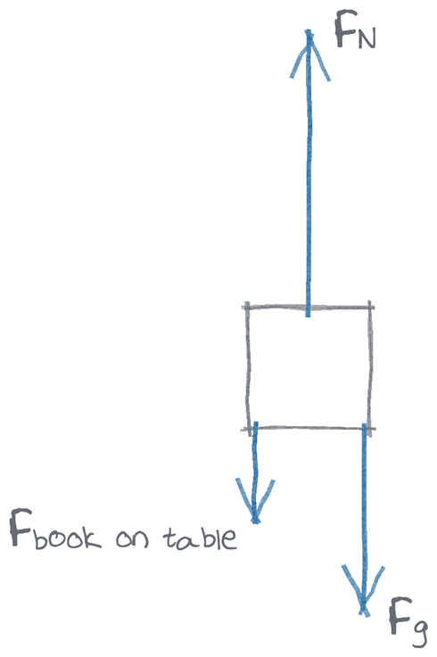
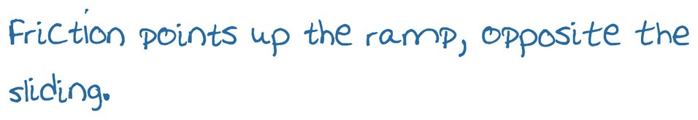 |  | 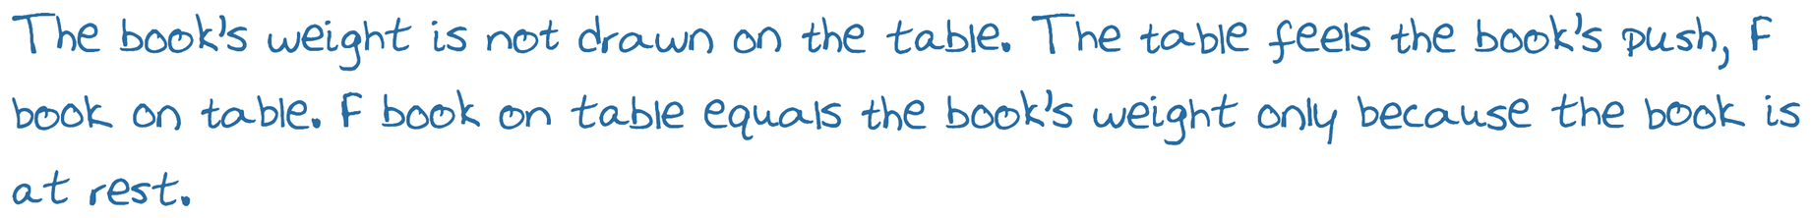

12. A block on a frictionless table is tied to a string. The string runs over a pulley at the right edge of the table to a hanging mass, and the mass falls and speeds up. Ignore the mass of the string and the pulley, and ignore air resistance. Draw two separate free-body diagrams: one for the block and one for the hanging mass.
Block • MULTI-TOPIC  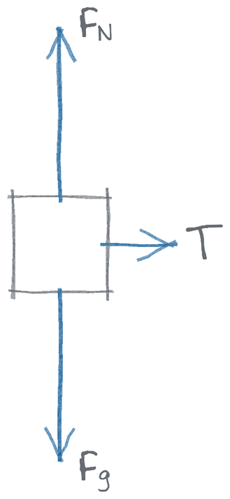 |  | Hanging mass  

